**[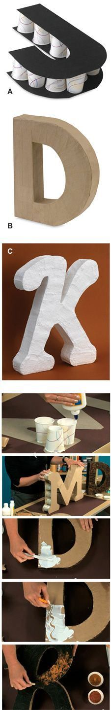](https://no.pinterest.com/pin/419468152779525982/)**

**[](https://no.pinterest.com/pin/419468152779526016/)**

**[paperflora.com](https://no.pinterest.com/pin/419468152779526013/)**

**[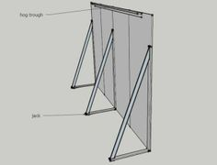](https://no.pinterest.com/pin/419468152779526013/)**

[Rediger](https://no.pinterest.com/pin/419468152779525982/)

**[instagram.com](https://no.pinterest.com/pin/419468152779526010/)**

**[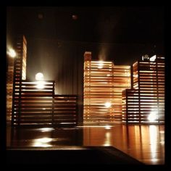](https://no.pinterest.com/pin/419468152779526010/)**

**[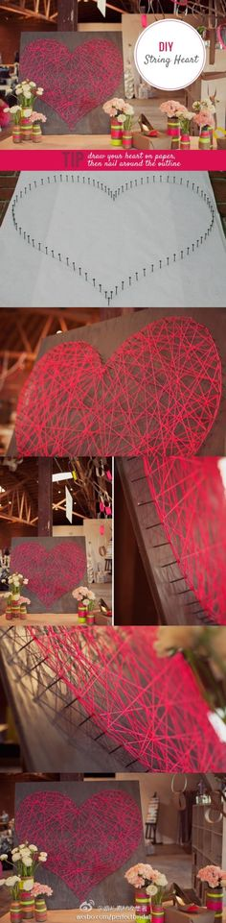](https://no.pinterest.com/pin/419468152779526005/)**

**[](https://no.pinterest.com/pin/419468152779526002/)**

[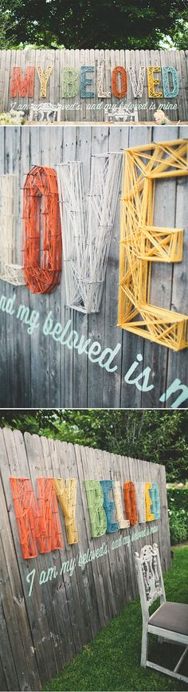](https://no.pinterest.com/pin/419468152779525998/)

**[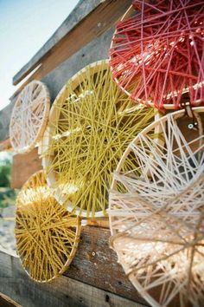](https://no.pinterest.com/pin/419468152779525994/)**